**199A Overview (Qualified Business Income Deduction)**

The Tax Cuts and Jobs Act (TCJA) was signed into law on December 22, 2018, along with section 199A.

**What is 199A?**

Beginning January 1st 2018 through December 31, 2025

A taxpayer (other than a C-corporation) is entitled to a 20% deduction of the taxpayer’s “***qualified business income***”

**What is qualified business income?**

1. Qualified Business Income (QBI) is the net income, (gains, deductions, and losses) from a qualified trade or business conducted within the US. This includes short-term and long-term capital gains and losses.
2. If an individual owns multiple businesses, QBI must be determined for each business separately.
3. Real estate income can qualify as QBI.

**What is not qualified business income?**

* Dividend income
* Any interest income
* Net gain from foreign currency transactions
* Income from national principal contracts
* Amounts received from an annuity
* Compensation (W2-Wages)
* Guaranteed payments

**Do I need to actively participate in the business to get the deduction?**

# No, your business interest may be “Passive” or “Active.”

**What is a qualified trade or business?**

A qualified trade or business, as defined under Section 199A, includes nearly all businesses except:

1. Employee services: Performing services as an employee does not qualify.
2. Specified service trades or businesses: Certain professions are excluded.
3. C Corporations: are NOT eligible.
4. Employees: Individuals must have an ownership interest in the business to qualify for the deduction.

**199A deduction limitation:**

The deduction is limited to 20% of **lesser of**

* Qualified Business Income

OR

* Taxable income **AFTER** reduction for any net capital gains, but **BEFORE** the 199A deduction is taken into account.

*Remember your taxable income is generally your adjusted gross income minus your standard deduction/itemized deduction. (AGI – Standard deduction/itemized deduction) = Taxable income.*

**Example:** *MFJ taxpayer**has the following:*

* *$100,000 of QBI (Qualified business income)*
* *$100,000 in Long-term capital gains*
* *($30,000 of tax deductions)*
* *Net taxable income in this example would be $170,000.*

*The 199A deduction is limited to the lesser of $20,000 ($100,000 x 20%) or $14,000 (20% of $70,000). The $70,000 is calculated by taking the total net taxable income of $170,000 - $100,000 capital gains) = $70,000*

*Result: In this example is $14,000 199A deduction. This means $14,000 of this person’s business income is no longer subject to tax.*

**Business and taxpayers who qualify for 199A Deduction:**

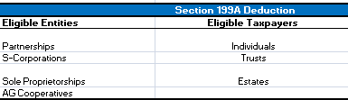

**Income limitations:**

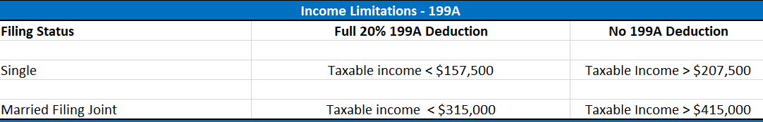

**Income Limitations: (Phase In)**

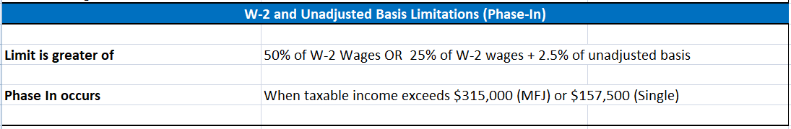

**Exception of 199A deduction for Specified service business:**

The deduction is allowed if the taxpayer claiming the deduction has taxable income of less than $315,000 (if married filing jointly; $157,500 for all other taxpayers).

Because the two W-2-based limitations also do not apply when taxable income is below those same thresholds, a taxpayer in a specified service business with taxable income below the thresholds simply deducts 20% of any qualified business income (subject to the overall limitation).

**Example**

A, a single taxpayer, is an attorney who operates his business as a partnership.

-The partnership pays no W-2 wages during the year. During 2018, A earns $100,000 from his law business and has total taxable income of $150,000.

Because A’s taxable income is less than $157,500, the prohibition on specified service businesses does not apply. In addition, because taxable income is less than $157,500, the W-2 limitations do not apply. As a result, A’s final deduction is $20,000 (20% of $100,000).

The ability to claim the deduction for owners of a specified service business is phased out over the next $100,000 of taxable income (if married filing jointly; $50,000 for all other taxpayers), so that by the time taxable income exceeds $415,000 (if married filing jointly; $207,500 for all other taxpayers) the deduction is lost completely.

Ex. Same facts as in the previous example, except A has taxable income of $230,000. Because taxable income exceeds $207,500, A is not entitled to any deduction under Section 199A.

**What is a Specified Service Trade or Business?**

**SSB SSTB**

*Specified Service Trade or Businesses & Examples*

* Law – Performance of legal services by attorneys, paralegals, and other similar professionals who serve in a legal service capacity.
* Accounting – Accountants, auditors , enrolled agents, and other similar positions that aid them in such a capacity
* Health- Doctors, pharmacist, nurse’s etc.
* Actuarial sciences
* Performing Arts – Actors, singers, directors
* Consulting
* Financial services – Those who provide wealth management, develop retirement plans, financial advisors. (Not disqualified: Bankers)
* Athletics – Coaches, team managers
* Brokerage Services
* Investing and investment management
* Trading
* Dealing in securities
* A business or trade where the principal asset is the reputation or skill of one or more of its employers or owners.

*Specified Service Trade or Businesses & Examples (continued)*

There are certain exceptions to the services mentioned above in the sense that they would not be classified as a specified service: Two examples

* In the healthcare industry – Manufacturing and sale of pharmaceuticals or medical devices would not be a specified service trade or business, because it does not directly relate to the medical service field.
* In the field of performing arts – Maintenance and operation of equipment or facilities for use in the performing arts would not be classified as a specified service business. Also persons who broadcast or otherwise disseminate video or audio to the general public would not be considered a specified service activity.

**Separating into multiple businesses entities will likely not help you avoid specified service business treatment:**

Example: Medical practice that performs medical services separates out its business into three separate partnerships:

* Partnership 1 performs medical services
* Partnership 2 owns and leases the real estate to partnership 1.
* Partnership 3 employee’s staff for partnership 1.

Because each entity is owned 50% or more common ownership all three partnerships will be treated as one specified service trade or business.

**Special de minims rules for businesses that sale products and provide services**

The regulations provide a de minims exceptionthat will allow a business that both sells product and performs services to avoid being treated as a SSTB.

If a trade or business has gross receipts of $25 million or less for the tax year, it will NOT be treated as a SSTB as long as less than 10% of the gross receipts of the business are attributable to the performance of services in one of the disqualified fields listed above.

If a business has gross receipts in excess of $25 million, a similar de minims rule exists; only 10% is replaced by 5%.

Ex. X Co. has annual revenue of $20 million. $18.5 million of the revenue is attributable to the sales of computers, and the remaining $1.5 million is attributable to consulting, installation, and training services. Because X Co.'s consulting services comprise less than 10% of X Co.'s total receipts, those services are ignored, and X Co. is not treated as a SSTB.

**Where to find more information:**

* **Irs Notice 2018-64** [**https://www.irs.gov/pub/irs-drop/n-18-64.pdf**](https://www.irs.gov/pub/irs-drop/n-18-64.pdf)
* **IRS 199 Proposed Regs:** [**https://www.irs.gov/pub/irs-drop/reg-107892-18.pdf**](https://www.irs.gov/pub/irs-drop/reg-107892-18.pdf)
* **IRS FAQ re:** **199A**: <https://www.irs.gov/newsroom/tax-cuts-and-jobs-act-provision-11011-section-199a-qualified-business-income-deduction-faqs>
* **Forbes article written by Tony Nitti:** [https://www.forbes.com/sites/anthonynitti/2018/08/09/irs-provides-guidance-on-20-pass-through-deduction-but-questions-remain/#e8c2c2c2ff84](https://www.forbes.com/sites/anthonynitti/2018/08/09/irs-provides-guidance-on-20-pass-through-deduction-but-questions-remain/%23e8c2c2c2ff84)
* **Article on 199A written by KPMG:** <https://home.kpmg.com/us/en/home/insights/2018/08/tnf-initial-impressions-proposed-regulations-irs-guidance-for-section-199a.html>